Oweless – Smart Expense Splitter (Web App)

# 1. Introduction

Oweless is a smart expense splitter web application designed to help groups of friends, roommates, and club members track and settle shared expenses fairly. It uses Supabase for real-time backend services, including authentication and database management.

# 2. Technology Stack

Frontend: Bolt.dev (low-code platform)

Backend: Supabase (Auth, Database, API)

Database: PostgreSQL (via Supabase)

Payment Integration: UPI Deep Links

# 3. Key Features

• Email/Password Authentication (via Supabase)

• Dashboard for managing groups

• Create and view expense groups

• Add expenses and split them among members

• View split summary – who owes whom

• UPI-based settlement links for instant payment

# 4. Supabase Database Schema

• users (id, email)

• groups (id, name, created_by)

• group_members (group_id, user_id)

• expenses (id, group_id, title, amount, paid_by)

• expense_split (expense_id, user_id, share)

# 5. Application Pages

## Login/Register

Allows users to sign up or log in using email and password. Supabase Auth handles authentication.

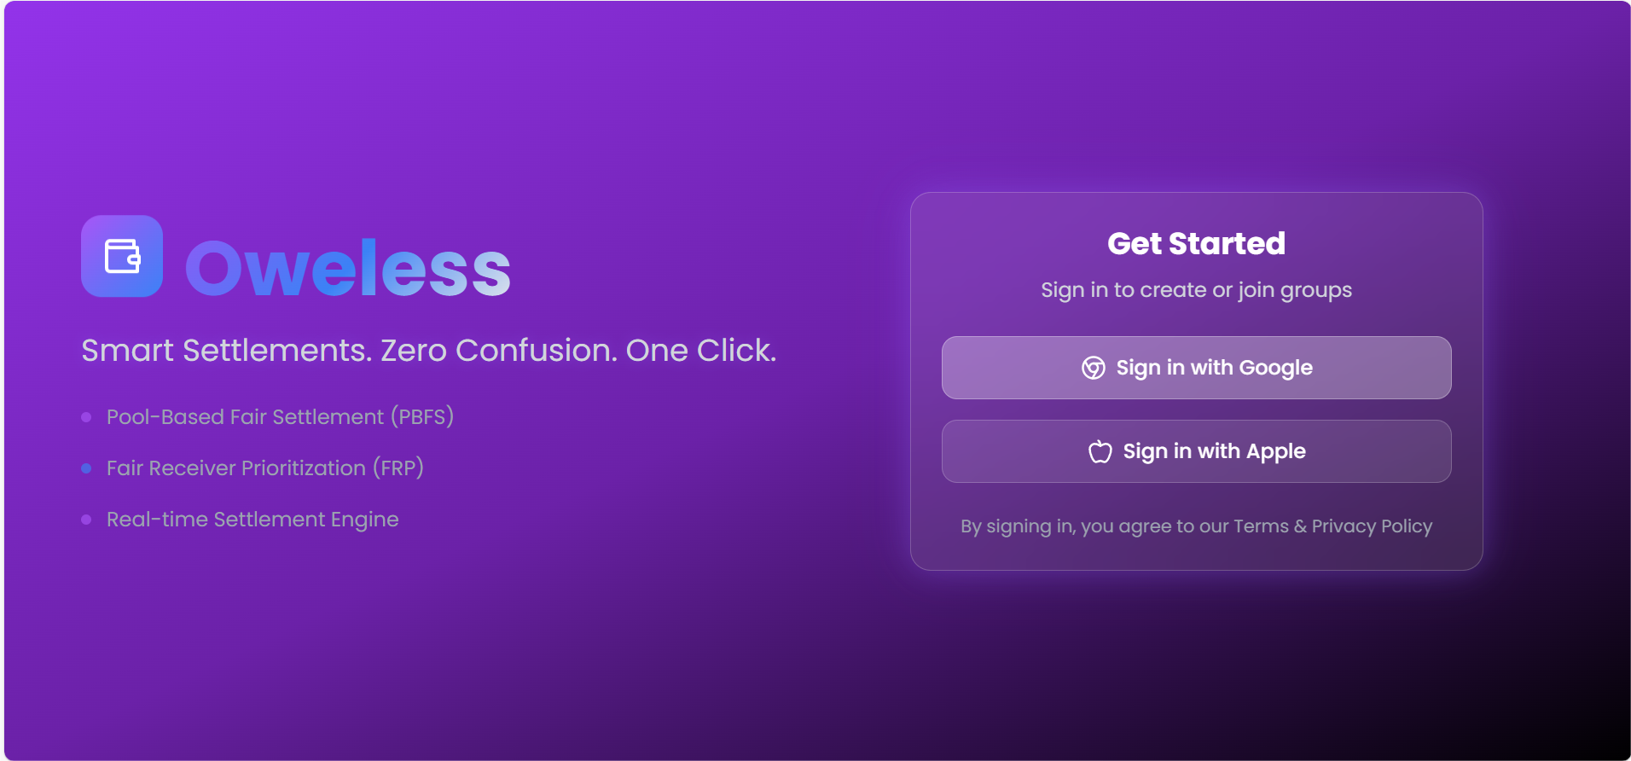

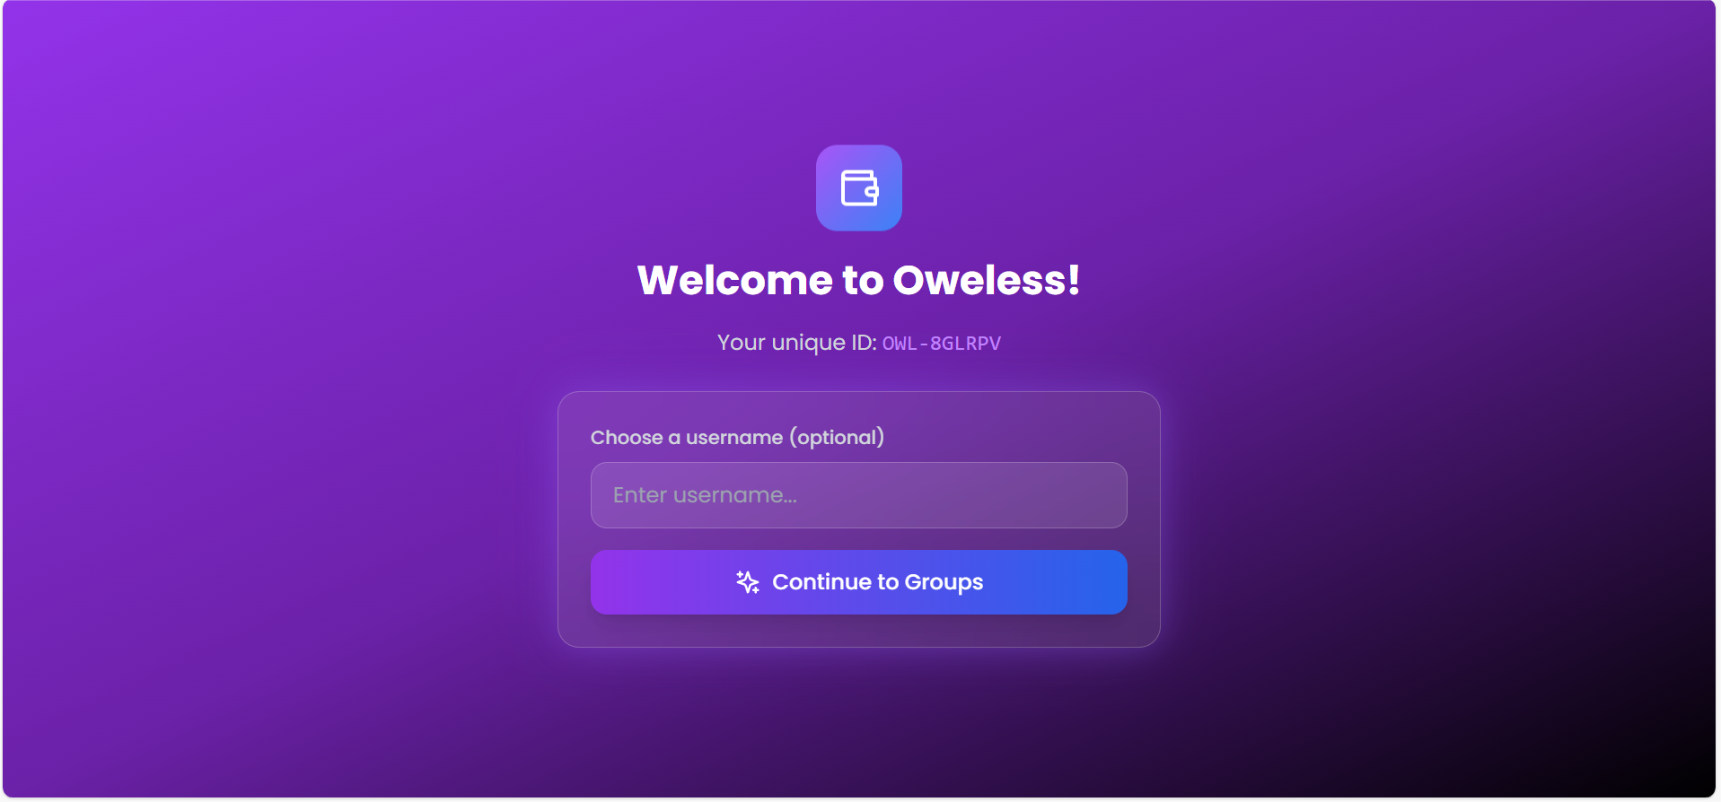

## Dashboard

Displays a list of all groups the user is part of. Option to create a new group.

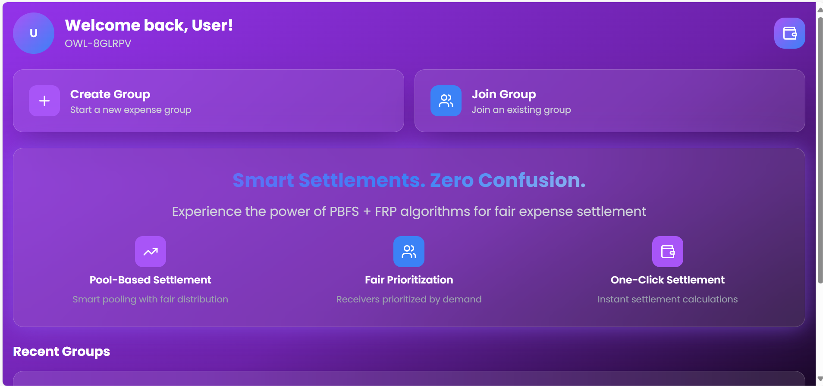

## Create Group

Form to enter group name and member emails. Submits to Supabase and creates a group entry.

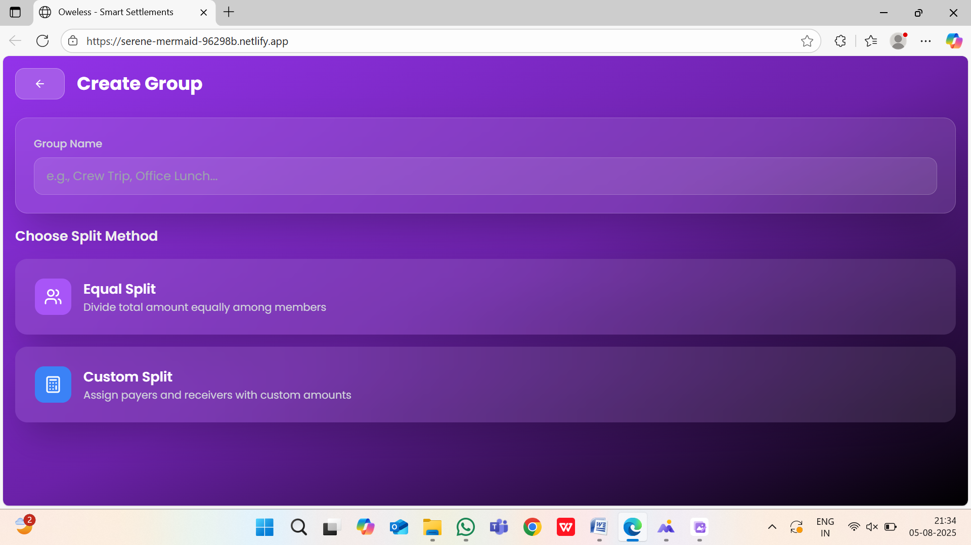

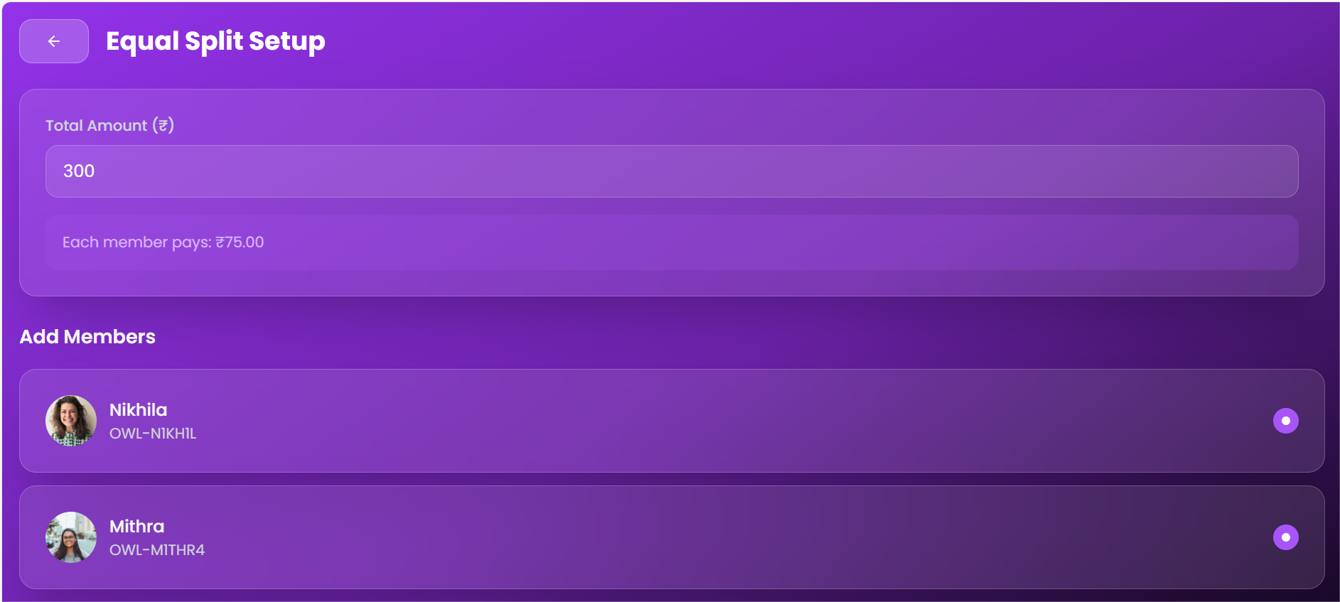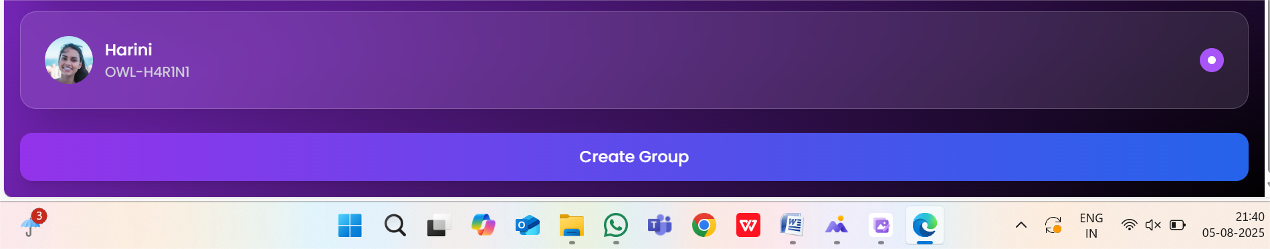

## Group Detail Page

Lists group members and expenses. Allows users to add expenses and view group activity.

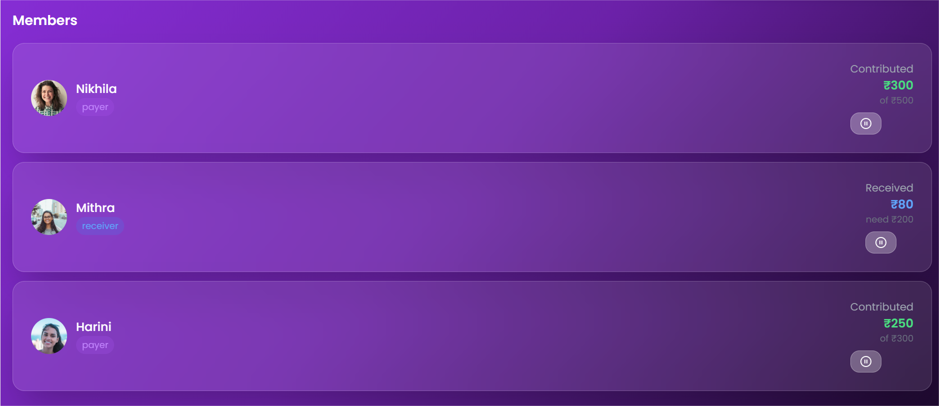

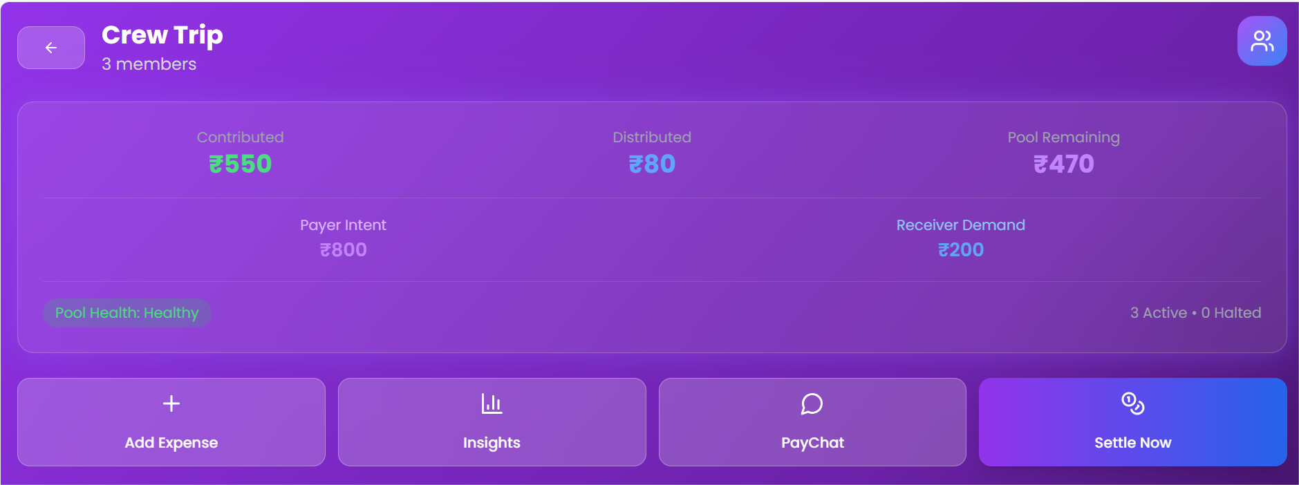

## Add Expense

Popup/modal form to add title, amount, who paid, and split among. Updates Supabase in real-time.

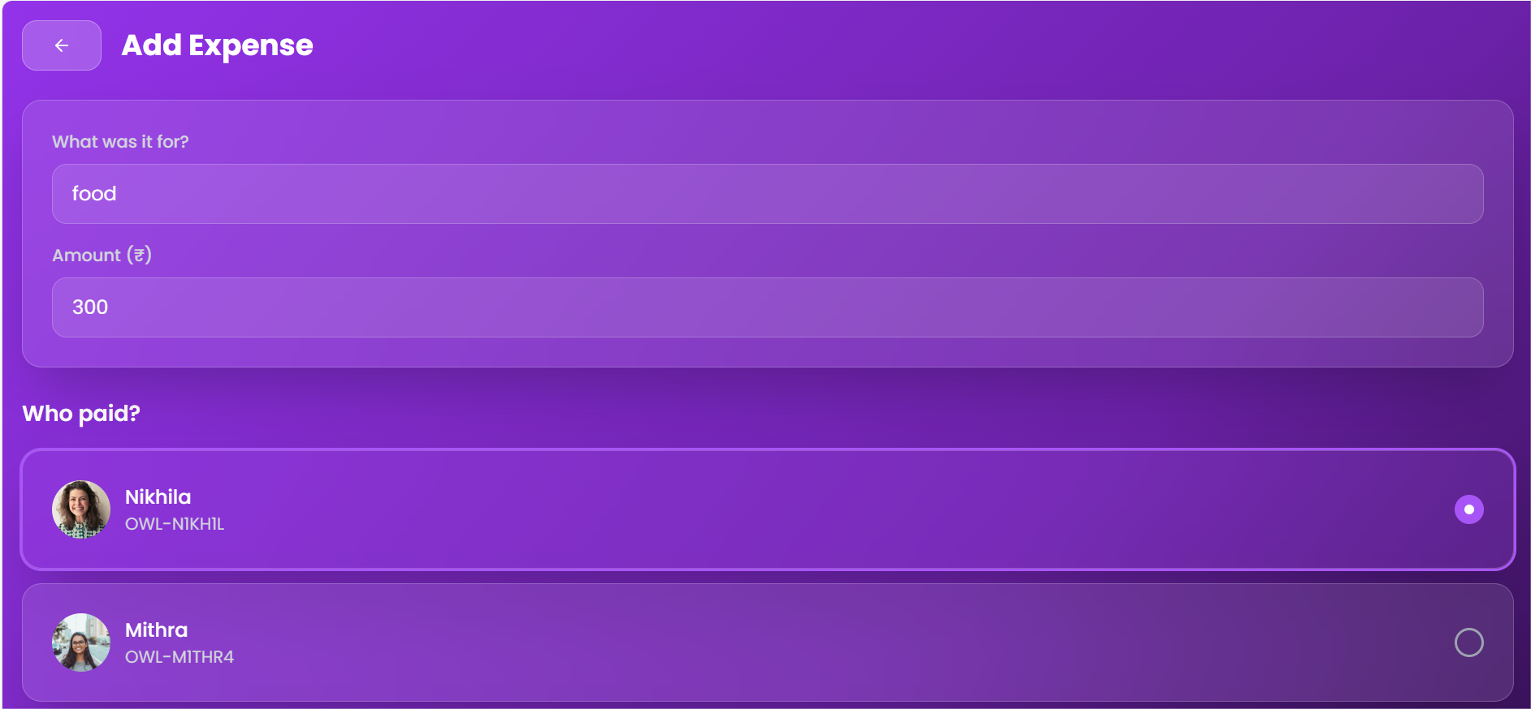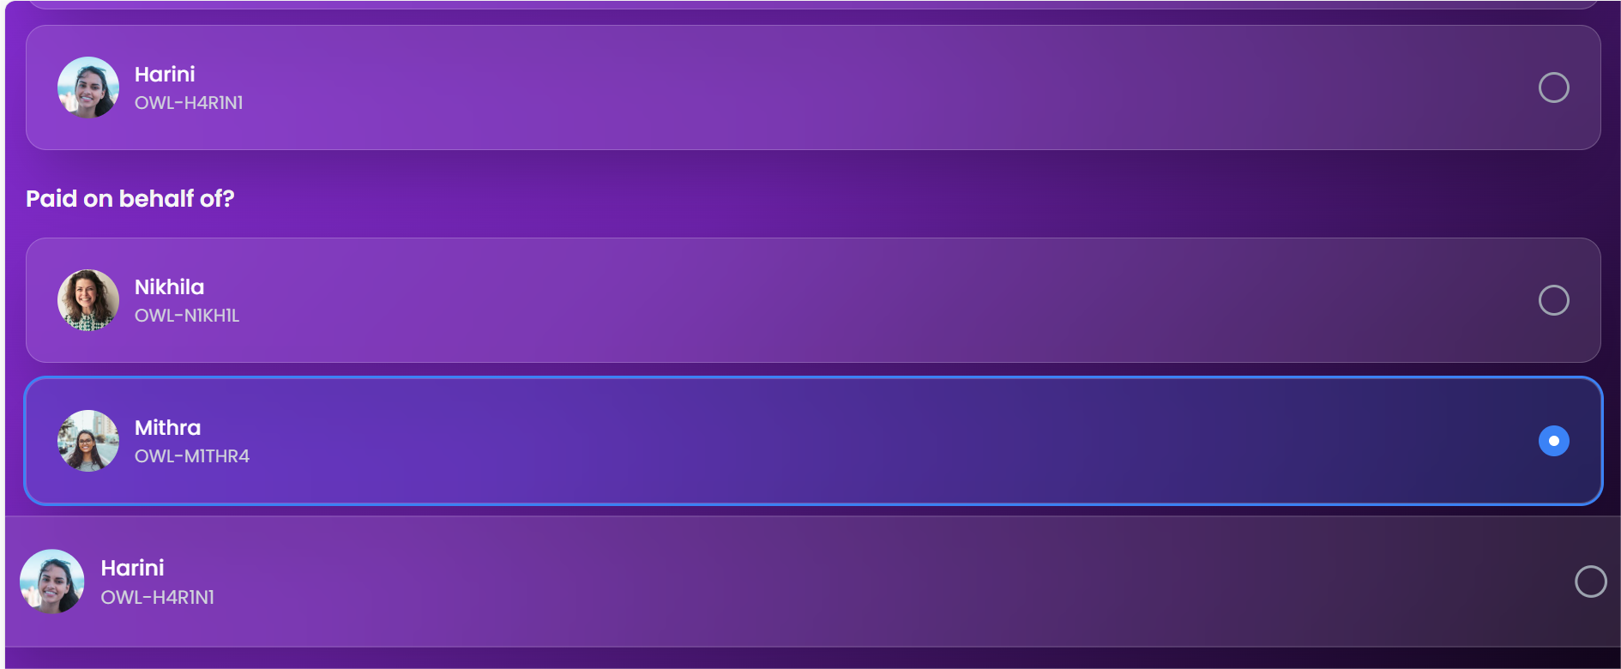



## Split Summary

Calculates balances and shows who owes whom. Offers UPI links for quick settlements

.

## Settle Up

Links to UPI deep link formatted URLs for real-time payment outside the app.

# 6. Conclusion

Oweless offers a simple, fast, and fair way to manage group finances. With a real-time backend powered by Supabase and a low-code frontend via Bolt.dev, it simplifies expense management for everyday groups.